**GHANA COMMUNICATION TECHNOLOGY UNIVERSITY**



**FACULTY OF COMPUTING AND INFORMATION SYSTEMS**

2022/2023 ACADEMIC YEAR - FIRST SEMESTER

GYARTENG ANGELA KONADU

4211212800

BIT L300 GROUP A – MORNING SESSION

IT 343: INTERNET TECHNOLOGIES AND WEB DESIGN

LECTURER: DR. WILLIAM BROWN-AQUAYE

**PROJECT REPORT ON INFOTECH. WEBSITE**

**LINK TO WEBSITE:** [**https://binfotechh.000webhostapp.com/Homepage.html**](https://binfotechh.000webhostapp.com/Homepage.html)

**APRIL 2023**

Table of Contents

CHAPTER ONE 3

1.0 INTRODUCTION 3

1.1 AIMS AND OBJECTIVES 3

1.2 SOFTWARE REQUIREMENT 4

1.3 HARDWARE REQUIREMENT 4

1.4 DEVELOPMENT TOOLS 4

CHAPTER TWO 5

2.0 INTERFACE DESIGN 5

2.0.1 THE NAVIGTION 5

Figure 2.00 5

2.0.2 HEADER 6

2.0.3 PAGE CONTENT (HOMEPAGE) 6

Figure 2.01 7

2.0.4 OUR COURSES 7

Figure 2.02,2.03 8

9

Figure 2.04 9

2.0.5 OUR SERVICES 9

Figure 2.05,2.06 10

2.0.6 ABOUT US 11

Figure 2.07,2.08 11

Figure 2.09 12

2.0.6 CONTACT US 12

Figure 2.1 12

2.0.7 THE FOOTER 13

Figure 2.2 13

Figure 2.3 14

Figure 2.4 14

2.1 SITE MAP FOR THE WEBSITE 15

CHAPTER THREE 16

3.0 CONCLUSION 16

# CHAPTER ONE

## INTRODUCTION

This website was created for BSc Information Technology 2024 year-group of Ghana Communication Technology University (GCTU) that specialize in delivering various services for its clients. BSc Information Technology 2024 year-group are a group of highly skilled and dedicated individuals. I chose the name **InfoTech.** to represent the class since we are Information Technology students. **InfoTech.**  offers a variety of technical services to their clients, their expertise ranges from web development to hardware solutions, UI/UX design, Graphic design, Sales of phones and accessories. With their passion for technology and creative problem-solving, the BSc Information Technology 2024 year-group of Ghana Communication Technology University (GCTU) have established themselves as a reliable and innovative provider of technical services.

Through their website, BSc Information Technology 2024 year-group year showcase their various services and provide clients with easy access to information and support. Clients can browse through the website to learn more about the different services offered by the class and get in touch with them for any technical needs. With their extensive knowledge and experience in the field, the class is committed to delivering high-quality services to their clients and ensuring their satisfaction. HTML, CSS and JavaScript (jQuery) make up the website's technology stack. The Home page (also known as the landing page), Our Courses page, Our Services page, About Us page, and Contact Us page are the five webpages that make up this website. It has a social media page linked to it which you can contact us from and learn more from there as well.

## 1.1 AIMS AND OBJECTIVES

* Increasing awareness of the brand among the target audience is important because it helps customers recognize and remember the company. This metric measures a company's ability to be recognized by its target market, making it an essential aspect of building brand recognition.
* Improving a company's search engine rankings for relevant keywords is crucial for attracting more traffic to the website. Higher rankings lead to more clicks and ultimately, more sales. Since more than 62% of customers use Google to search for products and services, appearing in the top search results is vital to reaching as many people as possible.
* Providing an excellent user experience on the website is essential to keeping customers engaged and satisfied. As users expect intuitive interfaces and seamless experiences, improving the user experience can help differentiate the website from its competitors and serve as a marketing tool for B2B digital content. By considering the needs of their clients and going beyond expectations, **InfoTech** can set a UX goal to ensure that their website meets the expectations of their target audience.

## 1.2 SOFTWARE REQUIREMENT

* Windows 10, Windows 8 or 8.1, Windows 7, Windows Vista, Windows XP, or Linux Operating System are the preferred operating systems for the development or a latest Operating System
* Internet Browser(latest of Google Chrome, Mozilla Firefox or Internet Explorer)

## 1.3 HARDWARE REQUIREMENT

* The computer for the application development must have the basic I/O components.
* Processing speed of 1Ghz or faster
* 20GB disk space or higher
* RAM of 1GB or higher
* It must have stable internet access

## 1.4 DEVELOPMENT TOOLS

Due to the nature of this project, different programming languages will be used for the different components of the system. The following tools will aid in the development of the project.

* Visual Basic Studio: An open source application for editing HTML and CSS scripts.
* HTML and CSS: These two scripting languages will also be used in designing and styling the user interfaces of the application.
* Web Browsers: Web browsers will be used to view the application within the service.
* JavaScript: Developers use it to create interactive and dynamic web pages, adding functionality to websites. JavaScript is primarily executed by web browsers, making it a client-side language that runs on the user's computer.

# CHAPTER TWO

## INTERFACE DESIGN

## 2.0.1 THE NAVIGTION

It consists of the navigation menus which also consist of pages linked together. It also contains the

navigation tag, the div tag, the link tag and the <ul> tags. It also has five href’s linked together, that is

the HOME, ABOUT US,OUR COURSES, OUR SERVICES and CONTACT US as shown in the Figure 2.00. The href

attribute specifies the link’s destination.

### Figure 2.00

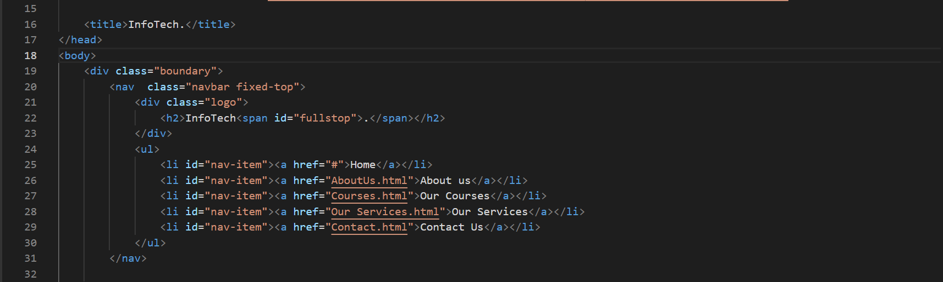

In HTML the <div> tag is used for defining a section of your document. With the div tag, you can group

large sections of HTML elements together and format them in CSS. The difference between the div tag

and span tag is that the div tag is used with block-level elements whilst the span tag is used with inline

elements.

## 2.0.2 HEADER

In HTML <header> tags represent a group of introductory or navigational sections. Headings are

defined with <h1> to <h6> with <h1> defining the most important heading while <h6> defines the least

important heading.

## 2.0.3 PAGE CONTENT (HOMEPAGE)

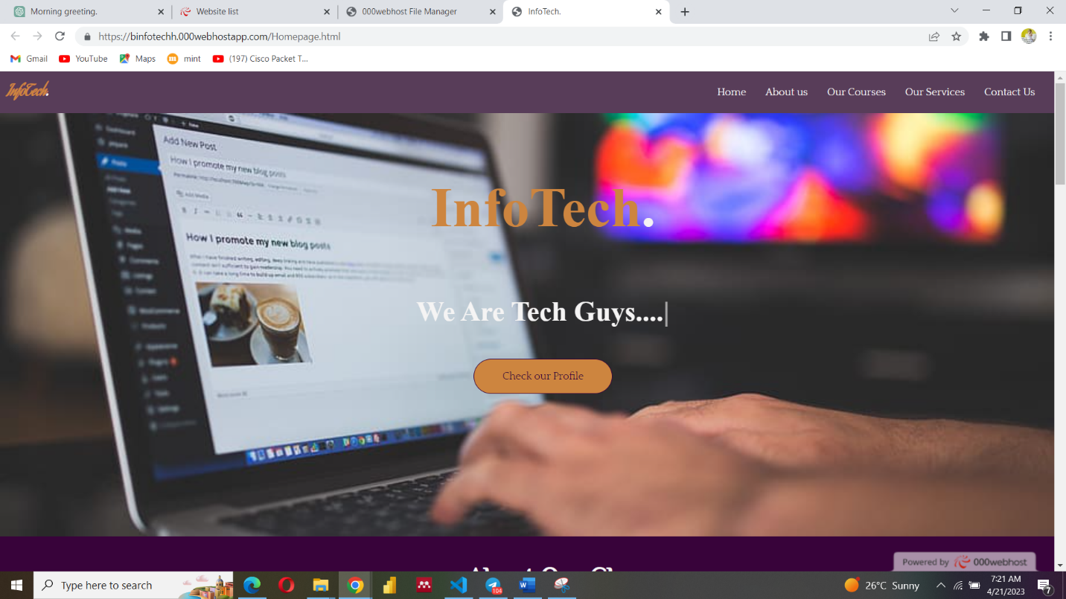This is the default or front page that visitors see when they load the InfoTech. website URL

### Figure 2.01

## 2.0.4 OUR COURSES

This page provides an overview of each program and give visitors a sense of what they can expect to learn and achieve through each course.

Here are some key elements that could be included on an "Our Courses" page:

1. Course Categories: Divide courses into categories based on subject or level. For example, categories could include "Software Engineering, Principles of Accounting, Database Management and Design, Principles of programming, Web Design and Internet Technologies etc.”
2. Course Descriptions: Provide brief descriptions of each course. This can include the course name, the instructor, the duration of the course, and a short summary of the topics covered. Also, highlight any unique features or benefits of the course.
3. Course Requirements: Indicate any prerequisites, such as prior knowledge or skill, that students should have before taking the course. Also, include any specific requirements, such as materials or equipment that students need to bring to the class

### Figure 2.02,2.03

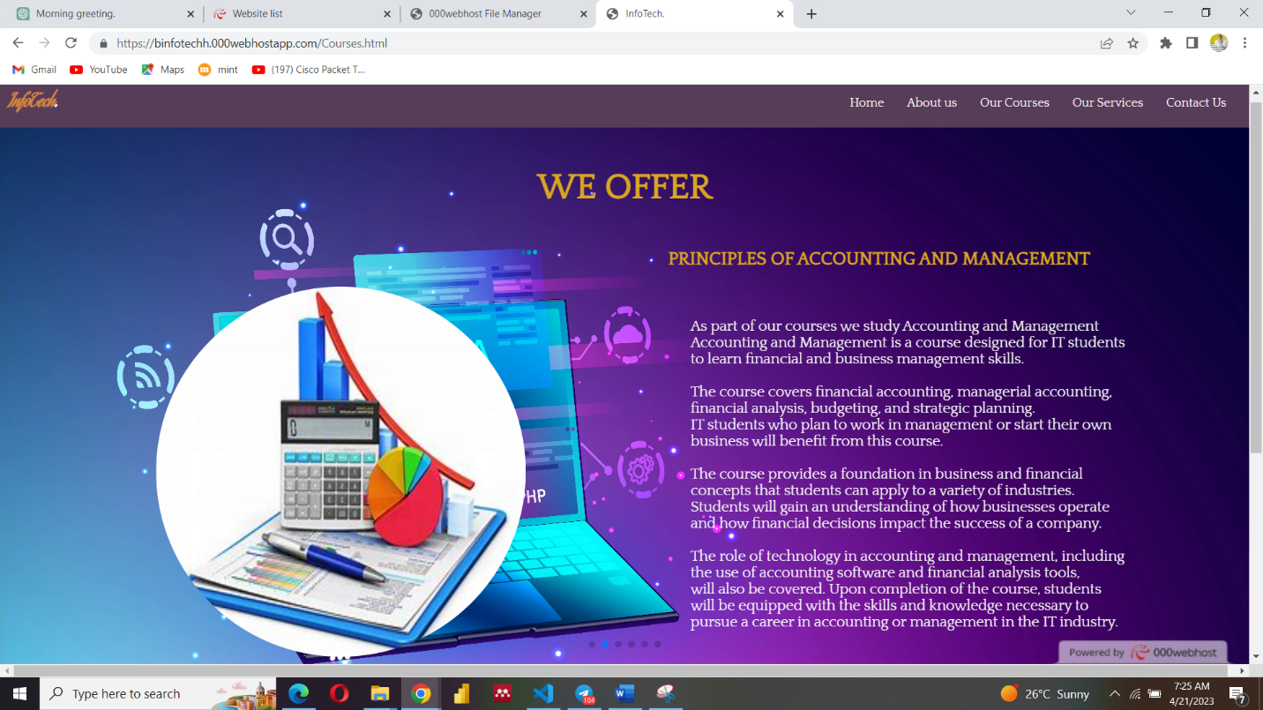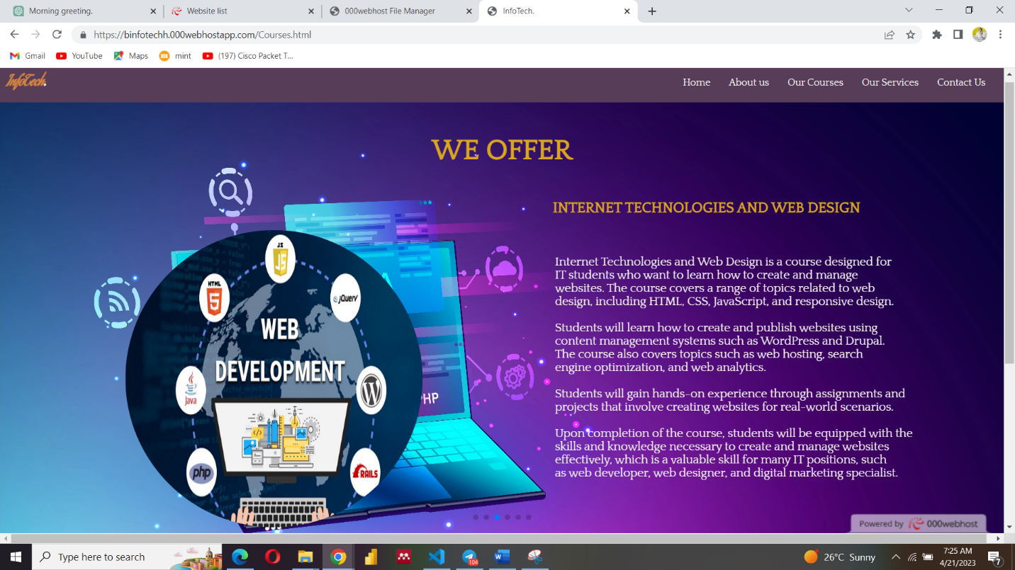

## 

### Figure 2.04

## 2.0.5 OUR SERVICES

An "Our Services" page on the class website that deals in phones and accessories, as well as provides hardware solutions and online shops, is an excellent way to showcase the various services and resources that the class offers. This page should provide an overview of each service and give visitors a sense of how they can benefit from each service.

### Figure 2.05,2.06

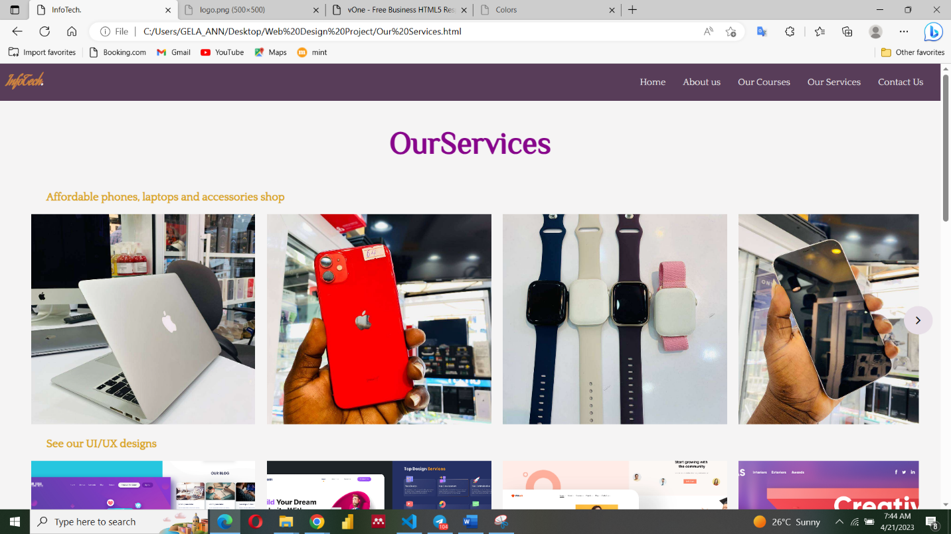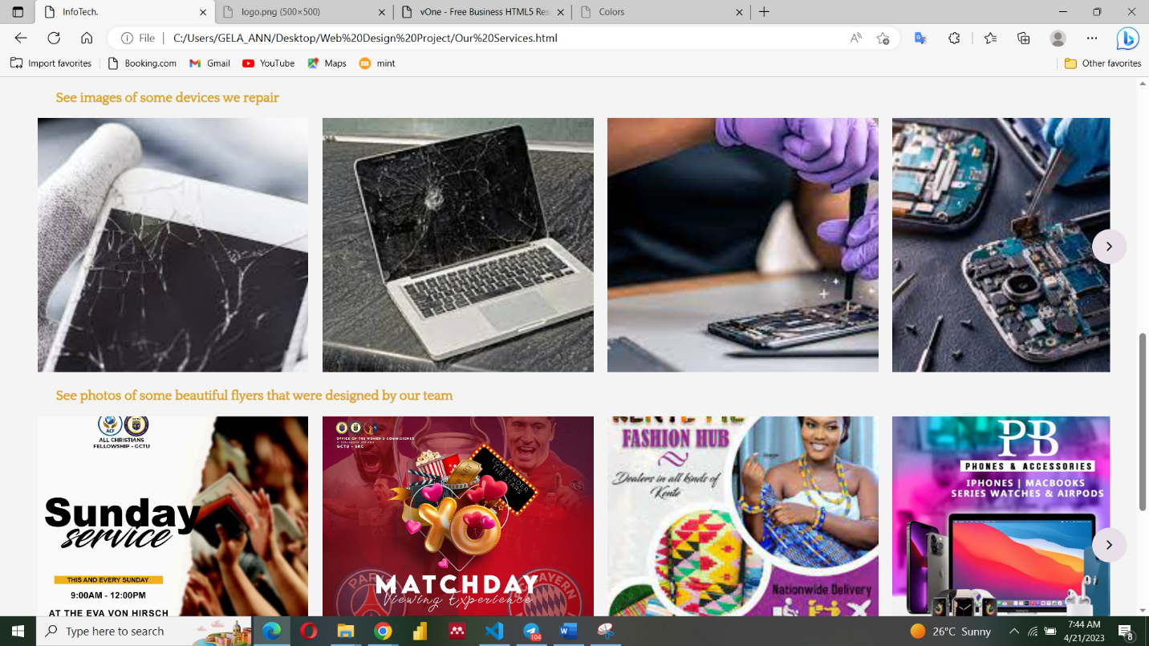

## 2.0.6 ABOUT US

Users browse to this page of the website to learn more about the website they're on. Readers will come

to this page for a variety of reasons and with a variety of questions, but my goal remains the same: to

inform them as to why they are on the site or why they should be on the site.

### Figure 2.07,2.08

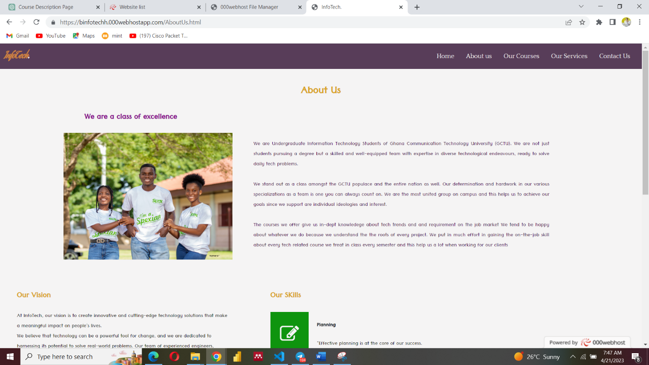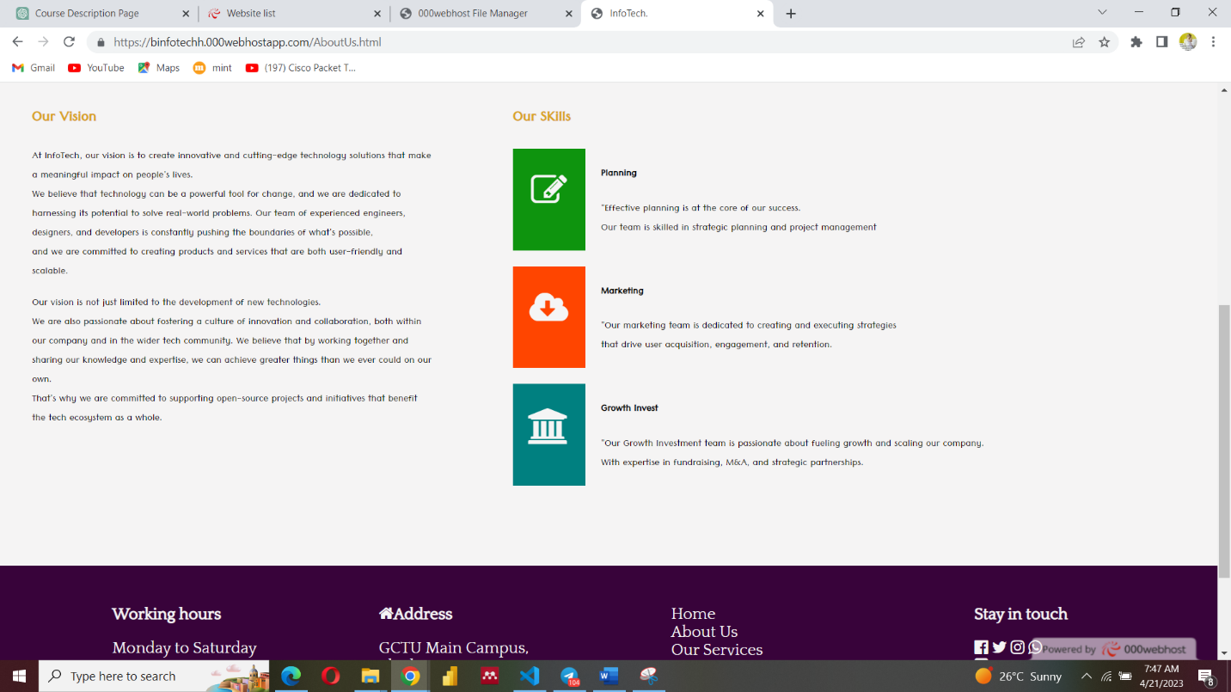

### Figure 2.09

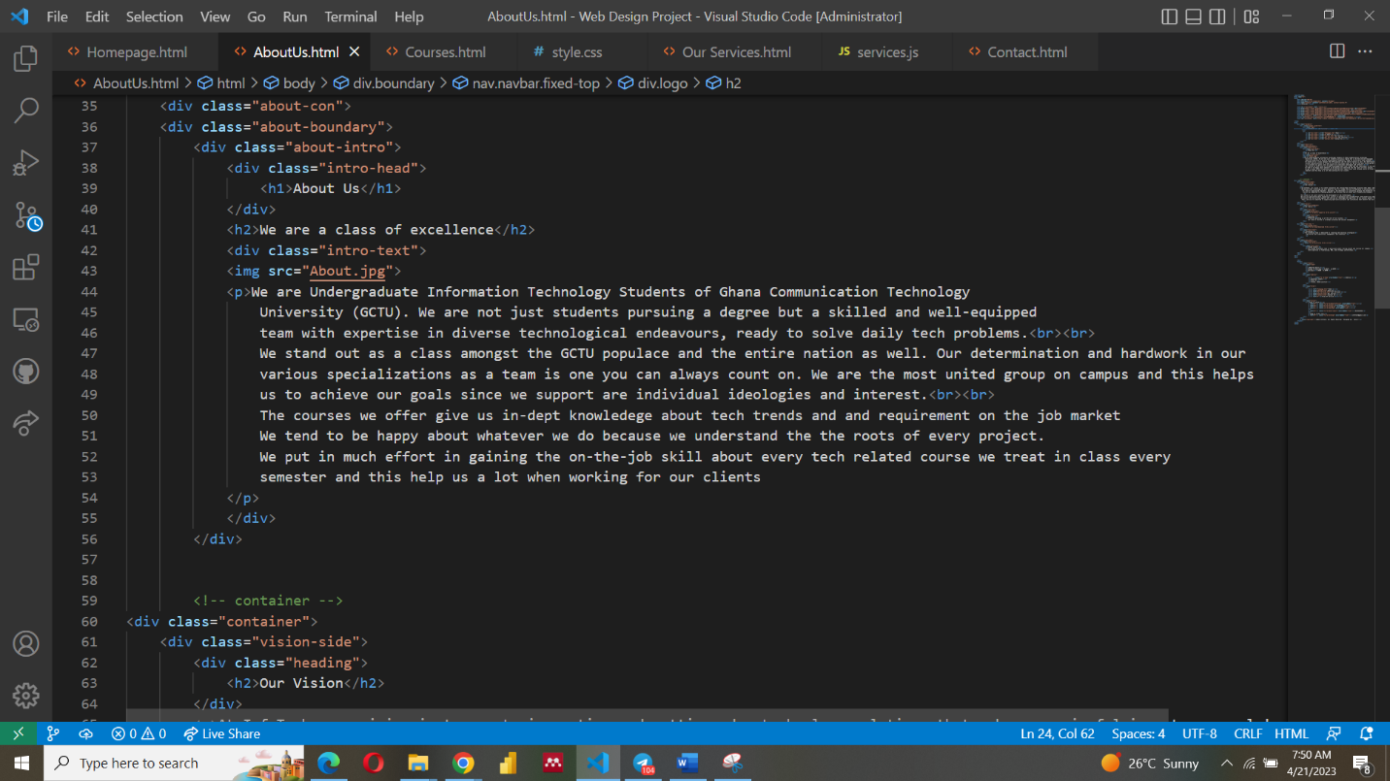

## 2.0.6 CONTACT US

This page provides a form that collects information such as name, email address, subject, and message,

and when entered, allows website visitors to contact the company.

### Figure 2.1

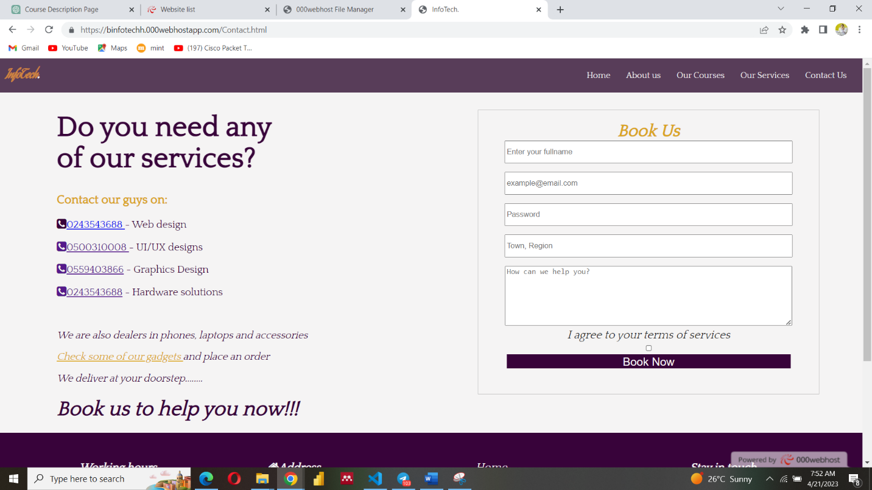

## 2.0.7 THE FOOTER

The <footer> tag defines a footer for a document or section. Its element should have information about

its containing element. It often contains information such as copyright notices, links to important pages,

and contact information. The footer can also be used for navigational purposes, allowing users to easily

access other parts of the website

### Figure 2.2

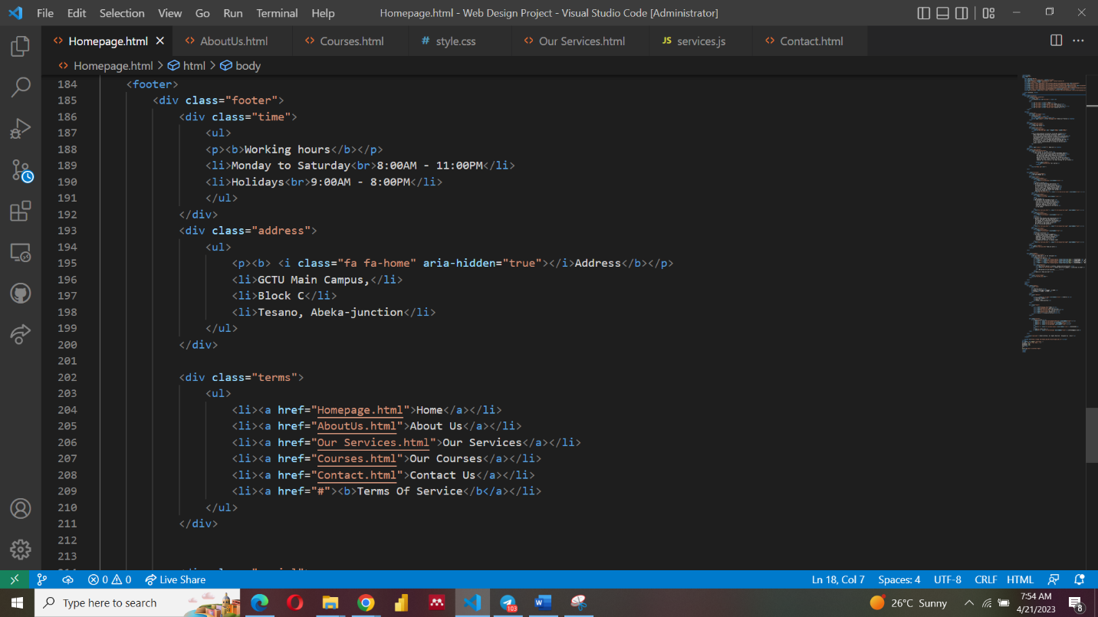

### Figure 2.3

### Figure 2.4

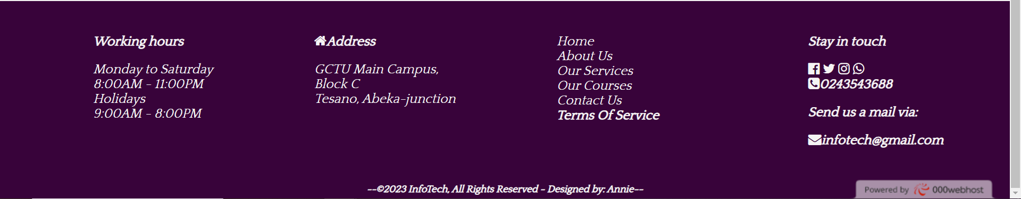

## 2.1 SITE MAP FOR THE WEBSITE

OurExpertise

Our Profile

ABOUT US

CONTACT

HOMEPAGE

OUR COURSES

OUR SERVICES

Our Courses

Top Section

About Our Class

Legend:

Webpages

Sections

# CHAPTER THREE

## CONCLUSION

To conclude, In conclusion, InfoTech is a flexible business that gives its customers access to a wide range of technical and creative services. InfoTech has made a name for itself as a dependable and creative provider of technical services because to its competence in web development, hardware solutions, UI/UX design, and graphic design. The business also sells phones and accessories, making it a one-stop shop for customers trying to fulfill their technology requirements. Through its website, InfoTech showcases its services and provides clients with easy access to information and support. The website offers a user-friendly interface and easy navigation, making it easy for clients to browse through the different services offered by InfoTech and get in touch with the company for any technical needs. With its commitment to delivering high-quality services and ensuring client satisfaction, InfoTech is a company that clients can rely on for all their technical and creative needs.